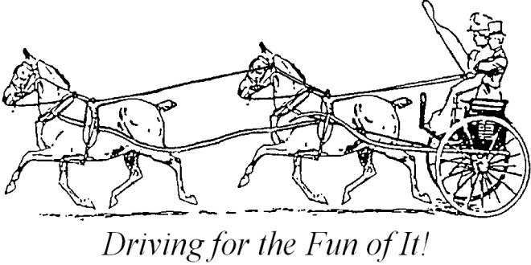

My Lady’s Manor Pleasure Driving Show
9:30 am Sunday, October 17, 2021
Spring Valley Park, 9777 Crest Rd, Glen Rock PA 17349
Judge: Mr. Bill Venditta
Technical Delegate: Dana Bright
Entries open: Sept 17, 2021 accepted via email to secretary Claire Lacey: laceyeqs@gmail.com
Entries close: Monday Oct 11, 2021 by 5:00 pm. Please use ADS PD entry form. Although we are not ADS sanctioned, we will run as an ADS competition, using the ADS 2021 Rule Book. To be considered complete, entries must include ADS PD entry form, Coggins test dated after 10/18/2020, equine flu vaccine after 4/18/2021, ADS pony height certificate, and MLMDC signed waiver. (If you do not have an ADS Pony Measurement certificate, we can measure ponies that morning.) Once your complete entry is received by the secretary, you will be sent a PayPal link for payment of entry.
Organizer: My Lady’s Manor Driving Club and Dana Bright cdeponyz@comcast.net
Secretary: Claire Lacey: laceyeqs@gmail.com
Veterinarian on call: Dr. Penny Grove
Class fees: there are 5 classes in a division. Entry fee is $60 for all 5 in a division. There is no cross entering divisions. (Turnout, Reinsmanship, Working, Timed Obstacles, and Pick Your Own Route) or $15 for individual classes. No post entries. Full refund if accompanied by doctor or vet certificate by 10/16. No stabling available.
Divisions: Open Horse, Open Pony, Open VSE, Novice Whip
Secretary’s Office opens: 7:30 am
Course Maps will be emailed in advance. Please print whatever copies you need.
Awards: 1-6th place for each class.

Schedule: 9:30 am Main Arena
- Open Horse Turnout
- Open Horse Working
- Open Pony Turnout
- Open Pony Working
- Open Horse Reinsmanship
- Open Pony Reinsmanship
- Open VSE Turnout
- Open VSE Working
- Novice Whip Turnout
- Novice Whip Working
- Open VSE Reinsmanship
- Novice Whip Reinsmanship

*** Classes may be split OR combined at discretion of organizer***

Timed Obstacles will be open for walking all morning in the Large Hill Arena.
Timed Obstacles will start approximately 12:30 with:
- Open Horse TO
- Open Pony TO
- Open VSE TO
- Novice Whip TO

Pick Your Own Route will be set up in the small arena as soon as last rail class is finished. We will allow time to walk.
- Open Horse PYOR
- Open Pony PYOR
- Open VSE PYOR
- Novice Whip PYOR

Misc Info: Any dogs on the grounds MUST be leashed, with Leash in hand.
Coffee and Donuts will be available in the morning. Contributions cheerfully accepted.
Please follow directions of parking crew. Parking is on hardtop. Water for horses available.
Directions: interstate 83, PA exit #8 (Glen Rock) at end of ramp go east on Rt 216 .2 miles then right onto Potosi Rd through 1 stop, 2.2 miles to Crest Rd on the left. Go over the top of the hill, park gates on the right. Follow MLMDC signs.

